Brycen McEuen
Professor Martinez
CS499
November 25, 2025
Artifact Two Narrative
My second enhancement for this project was done on my CS-360 Mobile Inventory Tracking app. This android application is a role-based inventory management system designed to help users track, update, and monitor item quantities. It was created earlier this year when I was taking the CS-360 Mobile Architect and Programming class. I chose this item because I thought the enhancement would demonstrate my ability to improve user-experience and security. The specific components that will be showcasing those abilities is the addition of role-based access, a search bar, and low-quantity alerts.
Implementing role-based access relies heavily on creating and modifying algorithms and data structures. For example, this utilizes algorithms through decision-making and permissions checking, using things like if-else branches to ensure each type of role only has access to their necessary components and features. It also utilizes data structures by storing roles in the database. The additional search bar also relies on algorithms and data structures for things like filtering and query operations. Lastly, the low-quantity alerts perform database indexing and linear searching to properly find and alert the user of low-quantities in the database.
The different roles that are included in this app include owner, administrator, and viewer. The owner of the database has access to everything, including adding/deleting/modifying items and promoting/demoting users. The administrator role has access to adding/deleting/modifying items, as well as only promoting viewers to the administrator role. Lastly, the viewers can only view the item list and see quantities (can not add/delete/modify items or promote/demote at all). Additionally, the low-quantity alerts will send a notification to all roles when an item’s quantity drops below five.
I believe that I did meet my course outcomes for this enhancement, because I’ll be designing solutions for a given problem (no way to filter items), demonstrating my ability to use innovative techniques and skills (quantity alerts), and improving overall security for the application(role-based access control).
Considering that I have limited experience with mobile app development, this was quite difficult to complete. The basic functionality I had before wasn’t too detailed or in depth, so the code really wasn’t all that complex, but the addition of role-based access control in particular was quite difficult. I think that was mainly because I had to make certain features invisible to certain roles, while making them visible for others, which was a concept I’ve never really encountered in coding before. While it was difficult, I still feel like I learned a lot and became a better programmer and software designer because of it.

Screenshots of additions:
New admin page for settings roles:
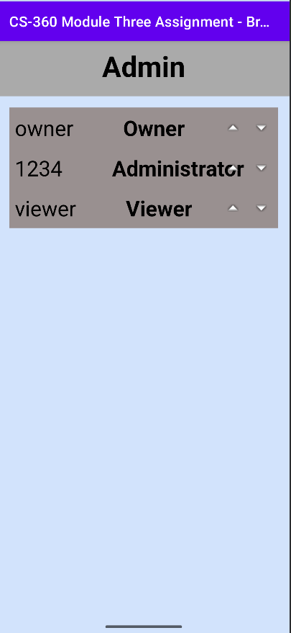
Search bar:
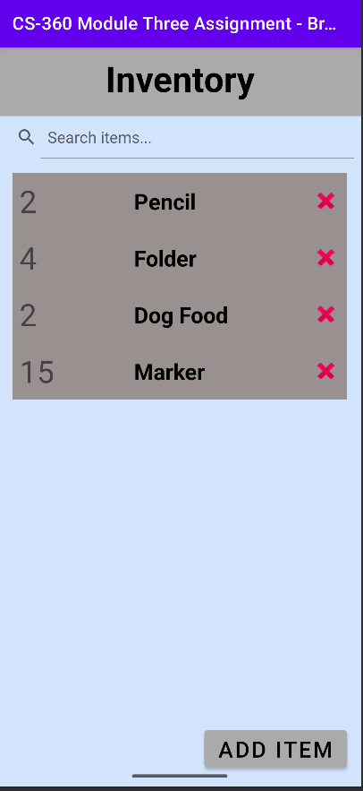
Low-quantity alerts:
